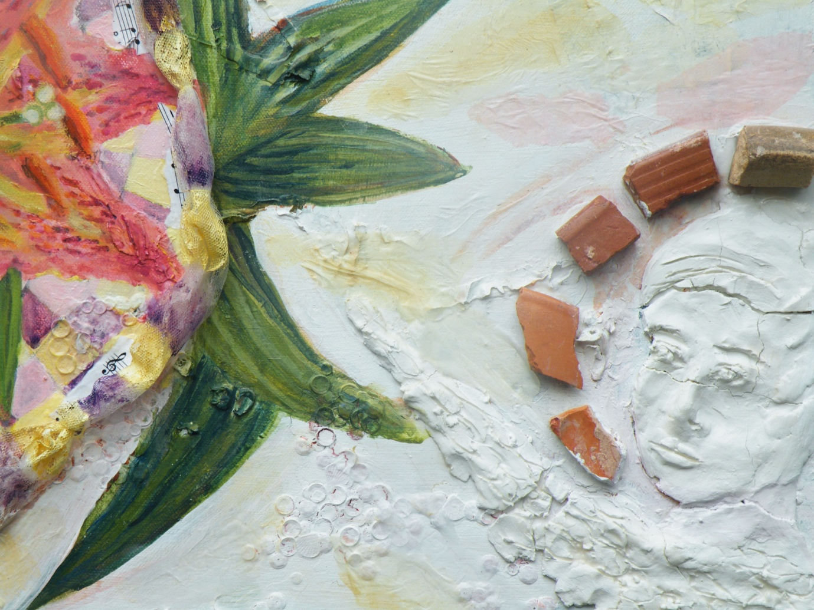

New Life (detail) Mixed media 2011 C. Ashenfelter
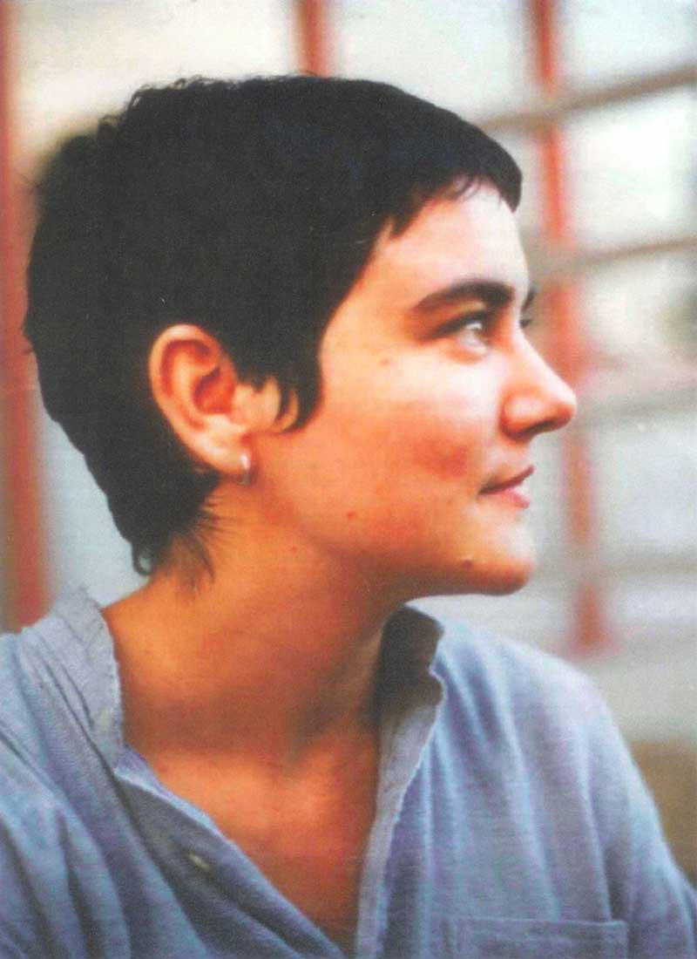
Sophia Mirza 1973-2005

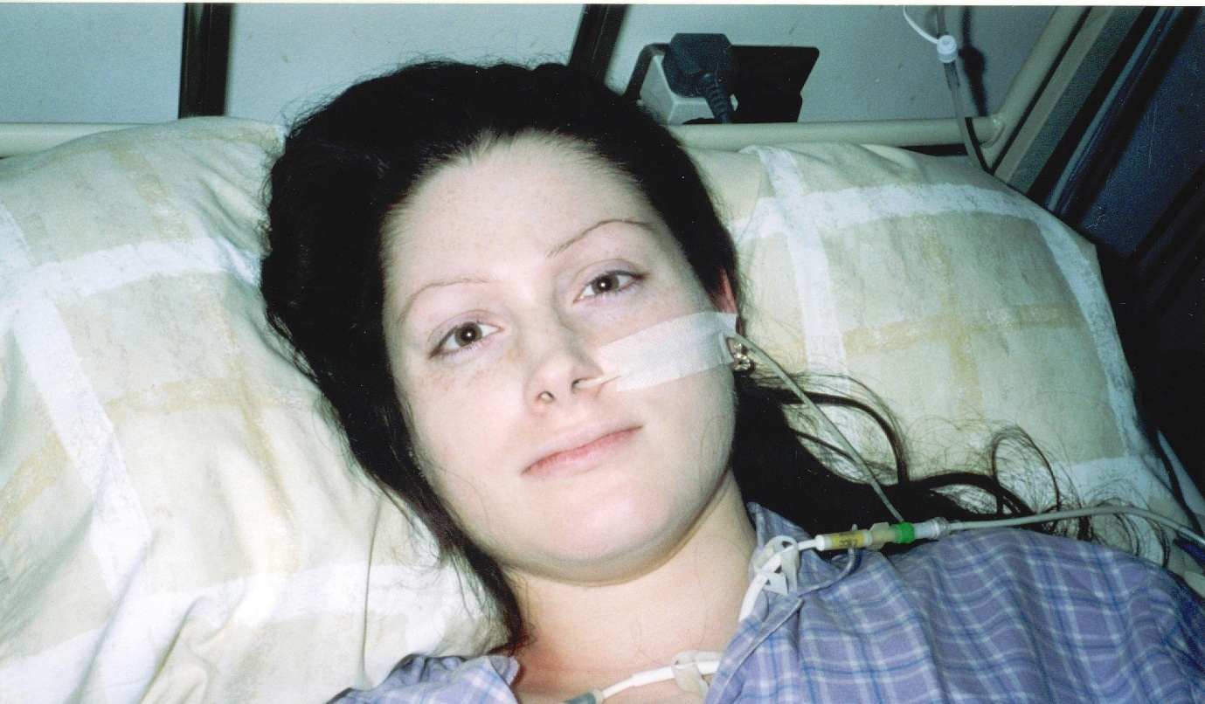

Lynn Gilderdale 1977-2008

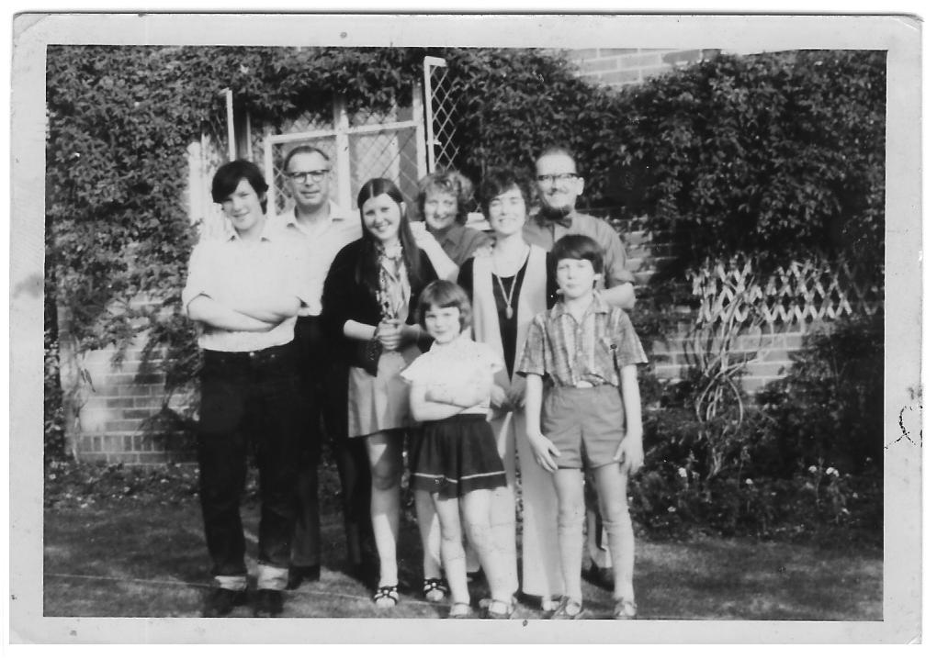

Family photo outside our house in Brook, Kent, 1970. Left-right: my brother Graham, Dad, my sister Rosemary, Mum, me at the front aged 6, two family friends and my brother Paul at the front.

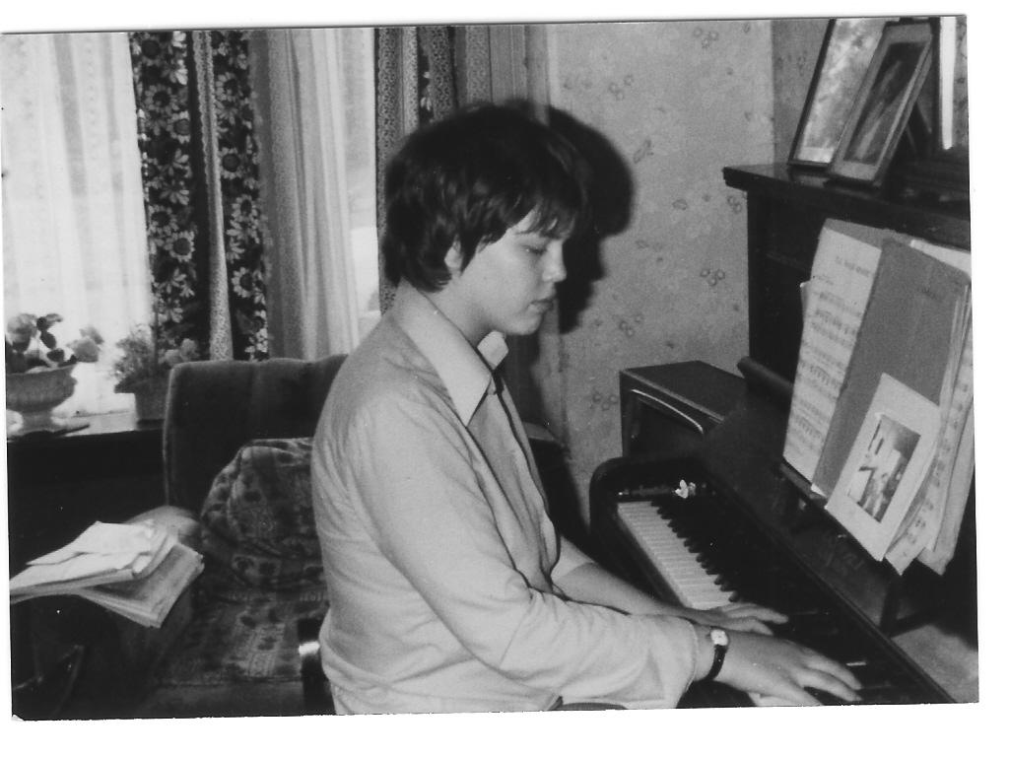
At a time of remission, three years into M.E. Here, playing the piano aged 17, at my Grandmother’s house in York.

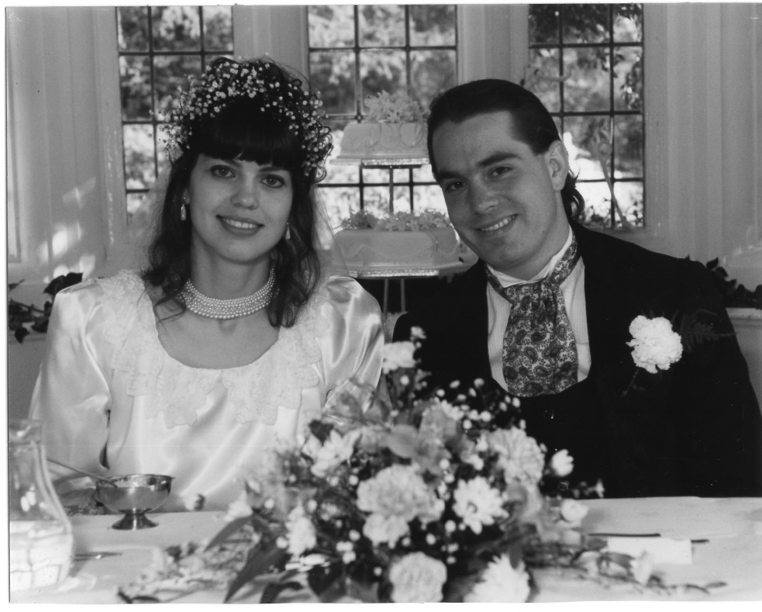
September 2nd 1989, our wedding day. John and me.
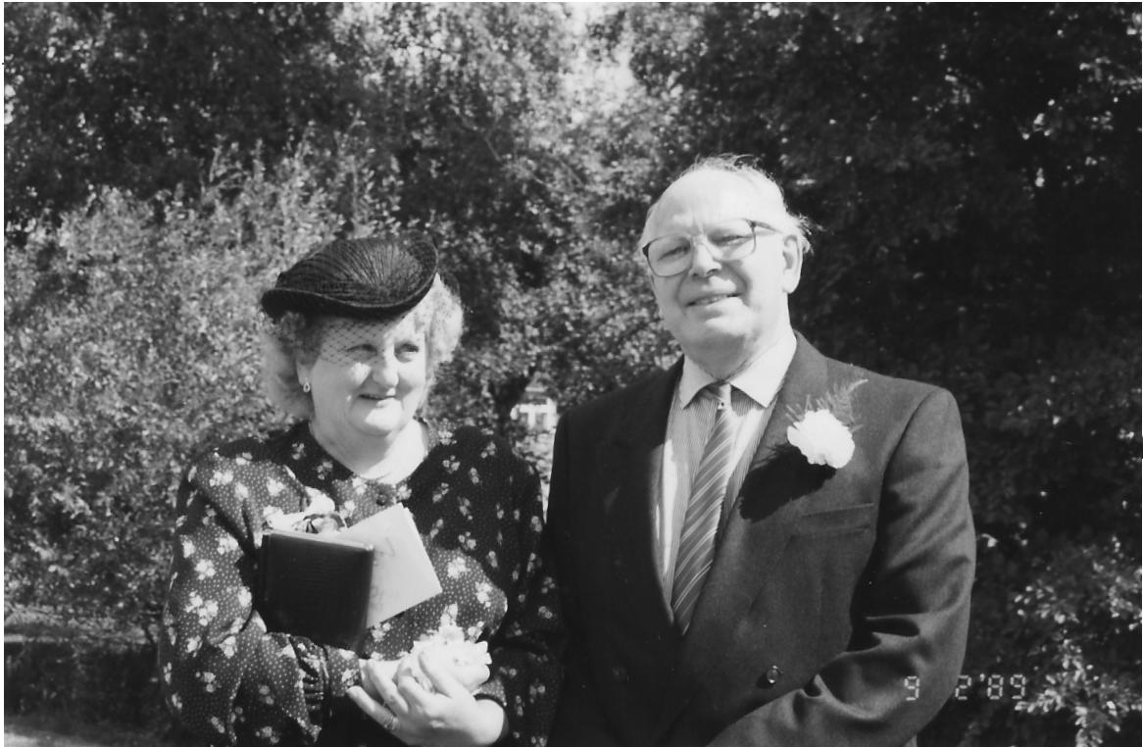
My Mum and Dad at our wedding, Hazel and Alan Turner.
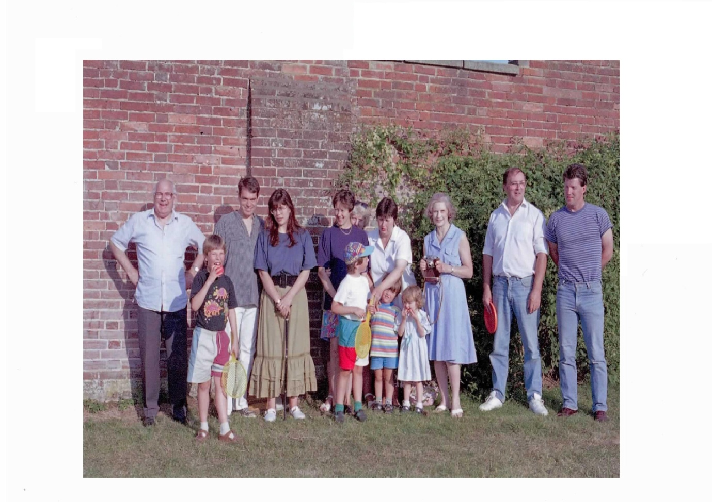
A family day out at Bedgebury Pinetum, Kent 1995. Left-right: Dad, Matthew (nephew), John, Me, Nicole (sister-in-law), Mum (hiding), Rosemary, James and Robert (nephews), Isabel (niece) in front, Aunty Joan, Bill (brother-in-law) and Graham.
Propped up with stick (detail of the day out.)

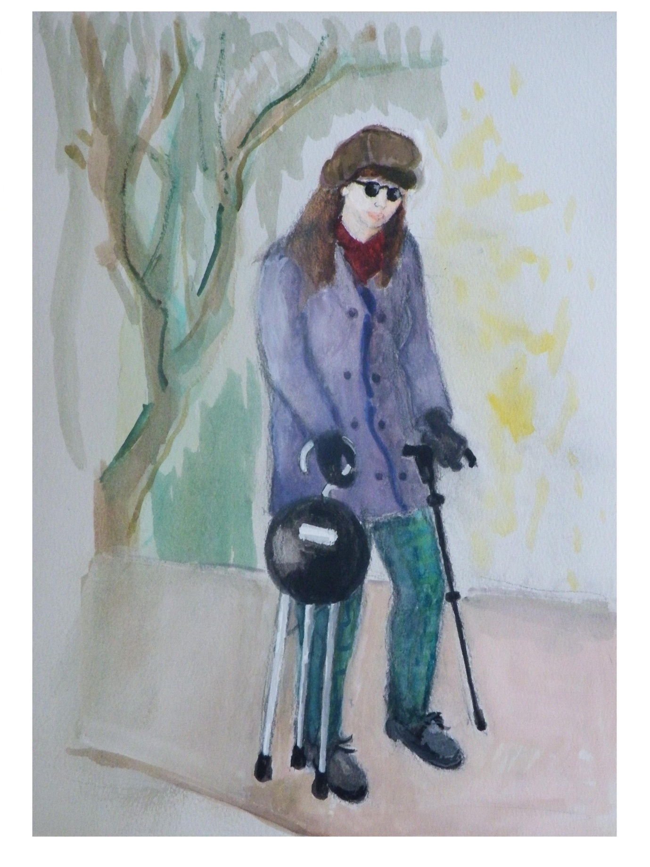

This painting is how many people remember me with M.E: dressed warmly with my seat-stick.

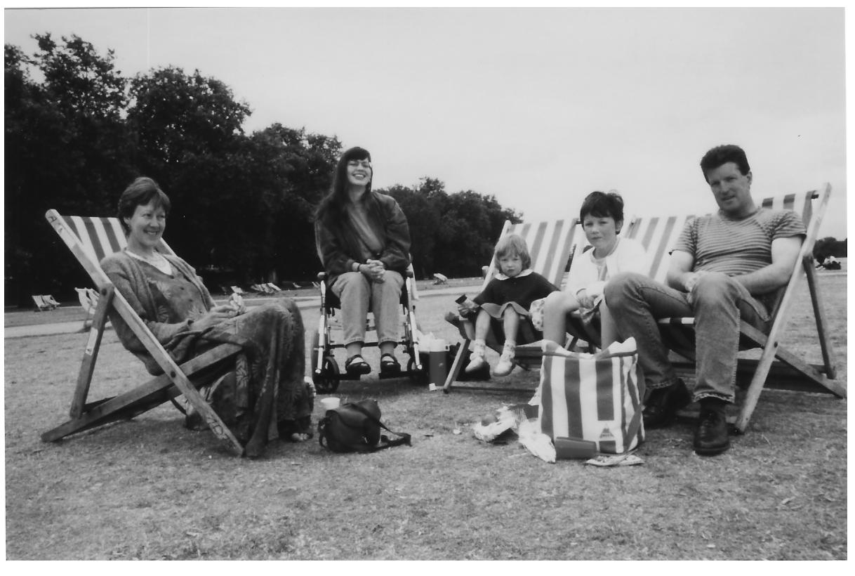

Family photo in Hyde Park, London, 1996. Left-right: my sister-in-law Nicole, me, niece Isabel, Melanie (Isabel’s friend) and Graham.

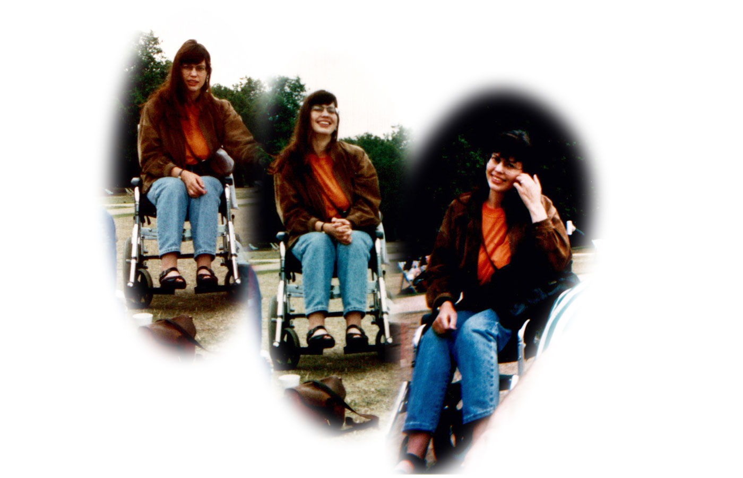
In Hyde Park, 1996

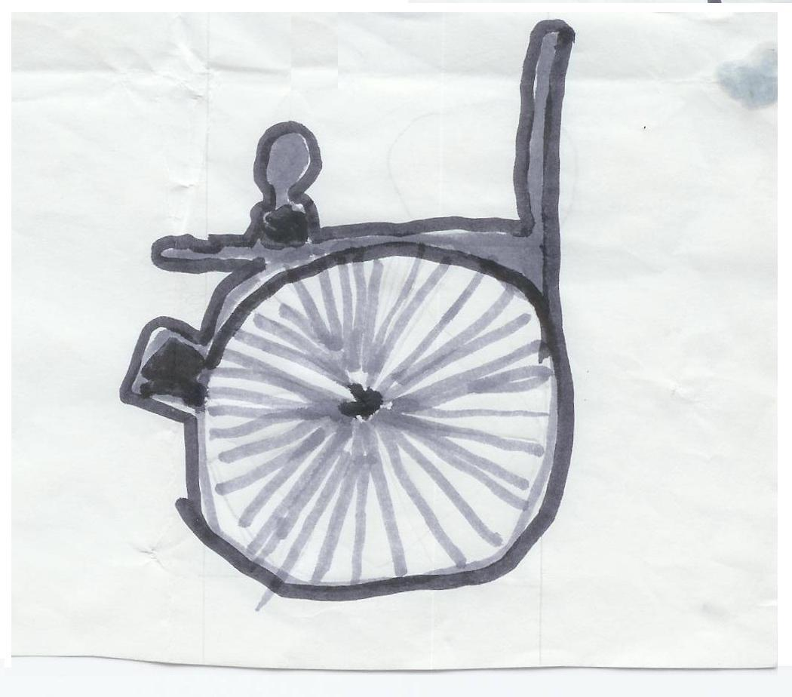
An Easter card drawn by my 9 year old nephew Matthew for me in 1997. The empty wheelchair was somewhat prophetic, as my healing occurred shortly afterwards.

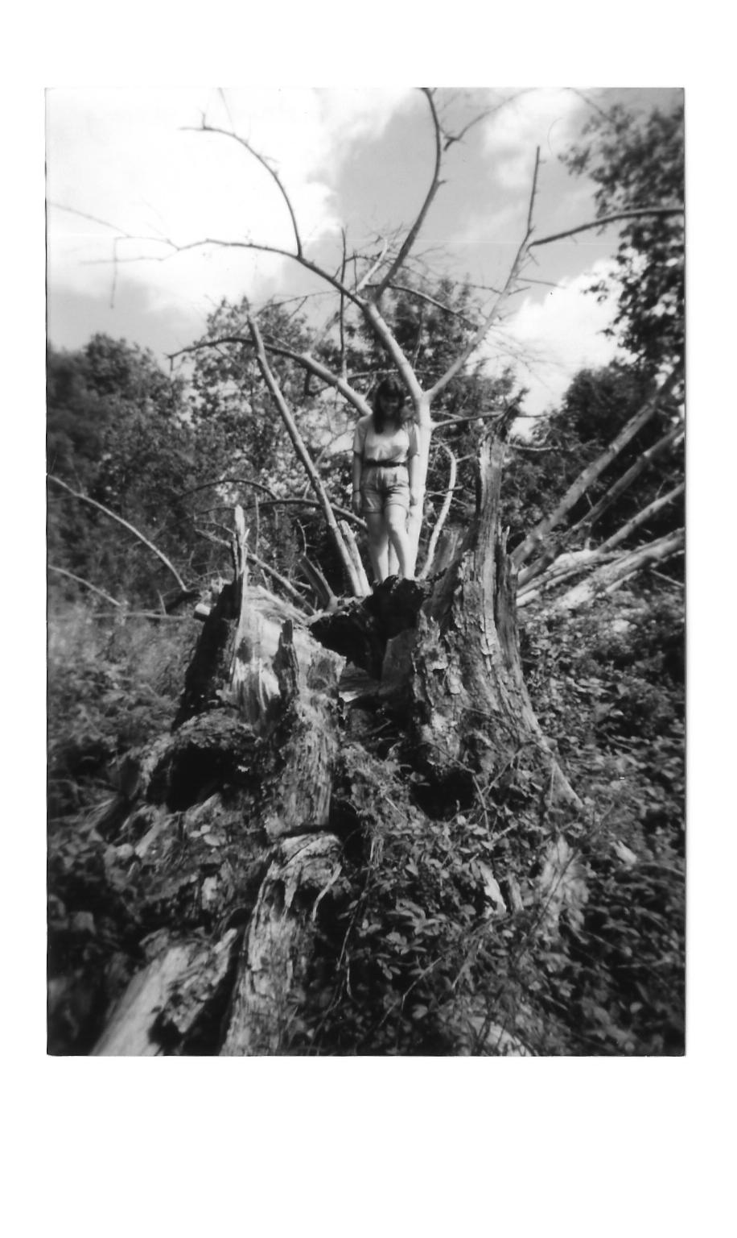
I climbed this huge fallen tree in Hawkhurst just two days after my healing. My legs were instantly strong after the prayer.

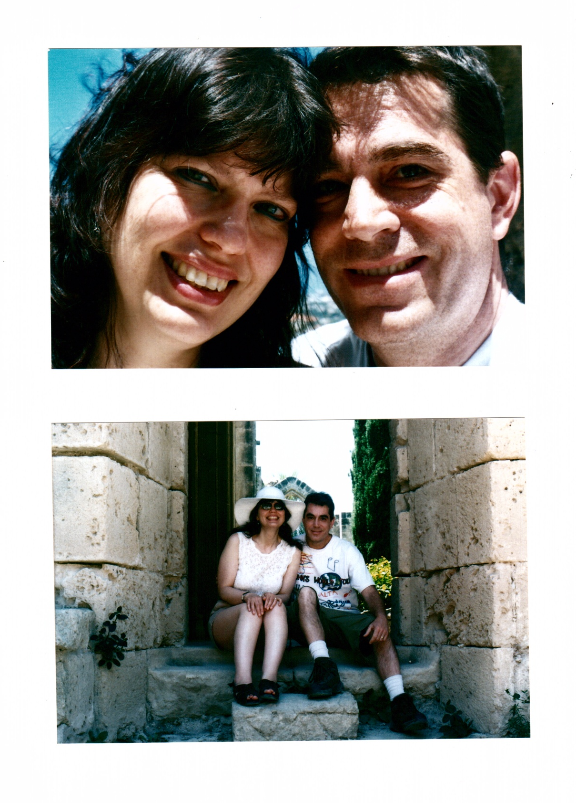
John and I on holiday in North Cyprus, 2008.
John and I posing.

Walking around Mediterranean ruins!

Working alongside other M.E. organistions....

Visiting Simon Lawrence in Troon, Scotland, 2007

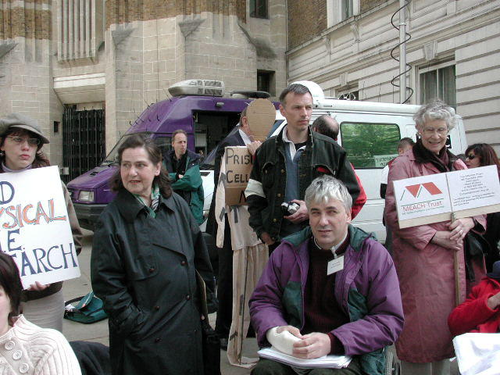

Demonstrating for a better M.E. deal, outside the Dept. of Health, London, 2003. I’m on left with hat and Simon Lawrence is on the right at the front. Simon is Chairperson for the 25% M.E. Group which supports the severest M.E. sufferers. (Photo comes with permission by MEACH.)

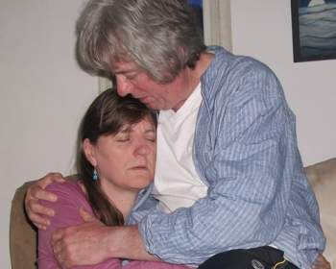

Linda and Greg Crowhurst have founded Stonebird, an organisation for severe M.E. sufferers.

Further details of these M.E. groups can be found at the back of this book.

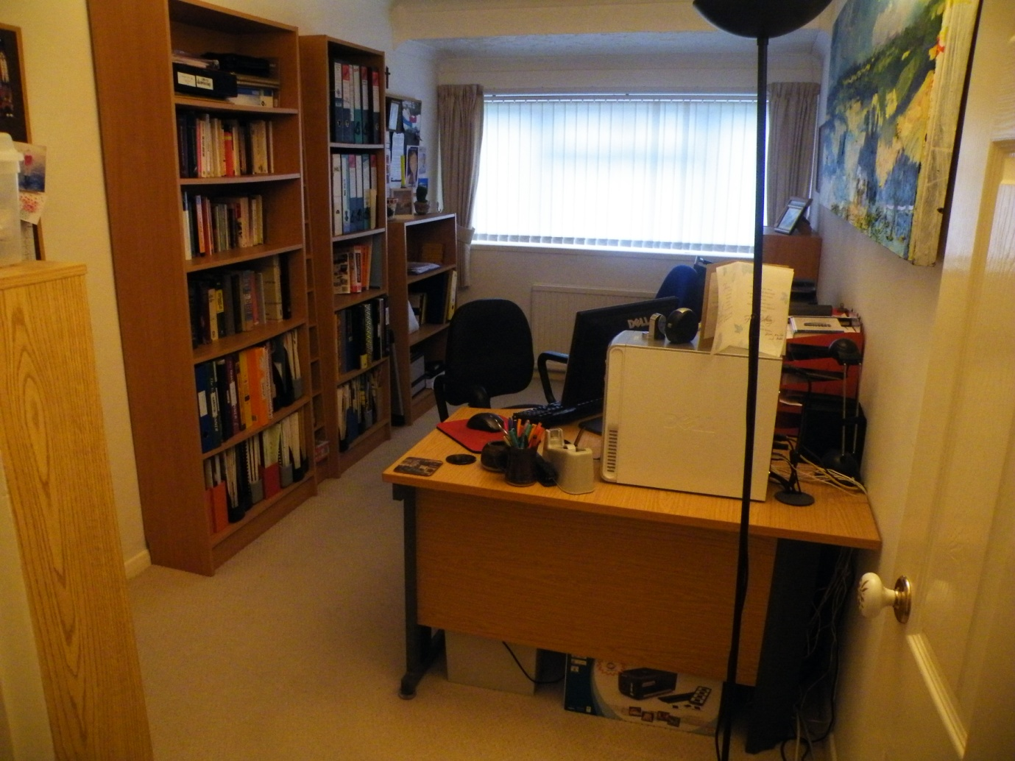

The Grace Charity Office 2011

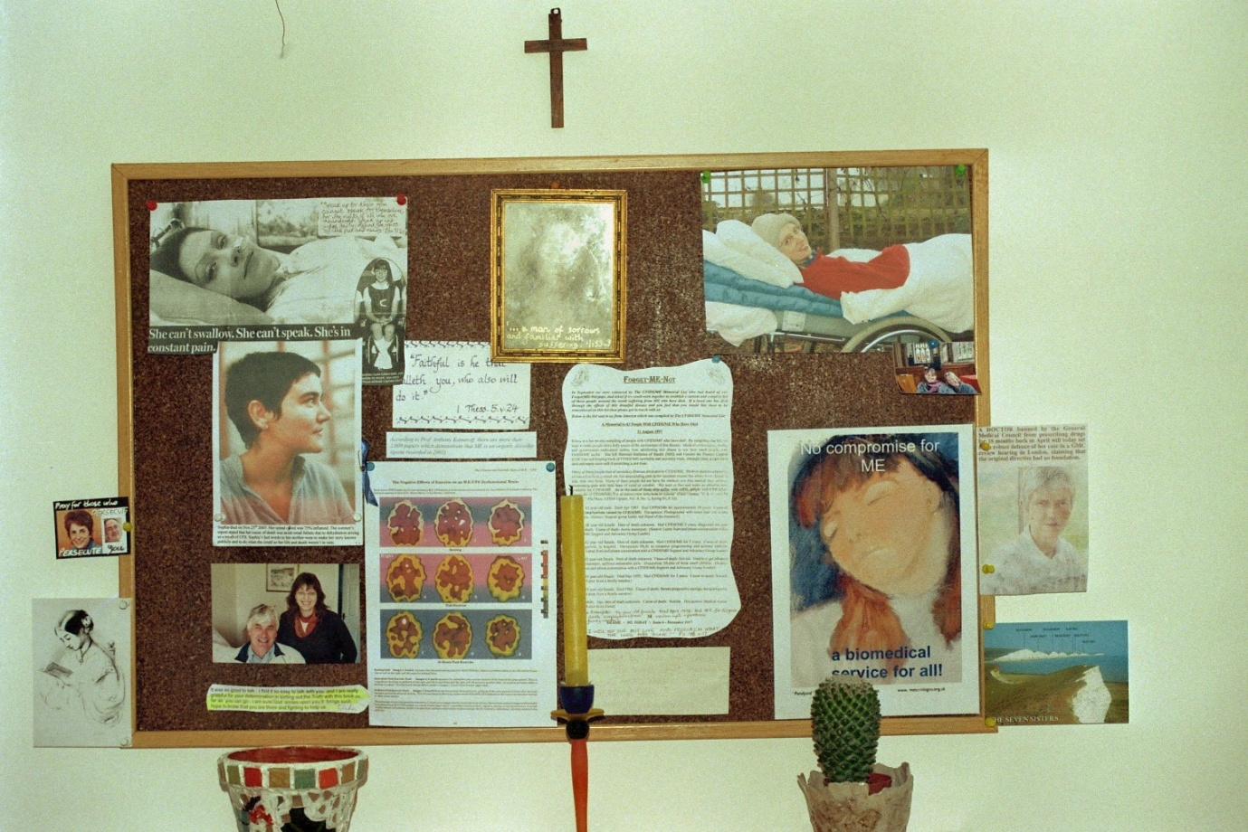

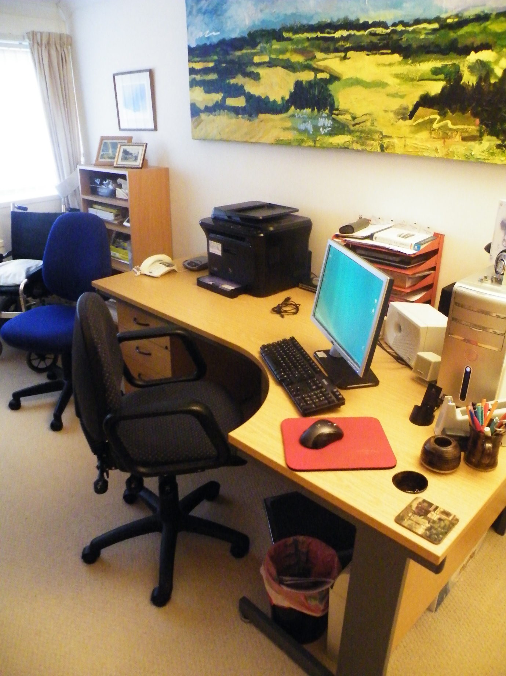
The Grace Charity Office 2011

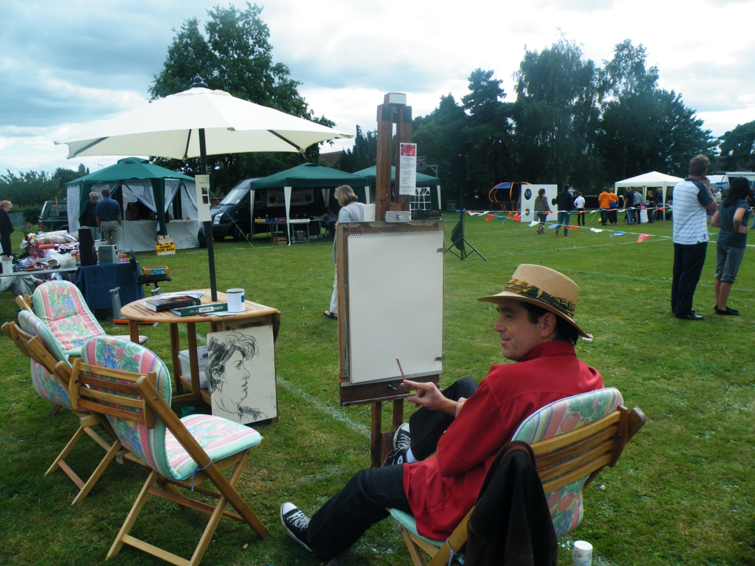

John fundraising for the Grace Charity for M.E. at our local village fete in Langley, 2011. He drew 13 portraits in 3 hours!

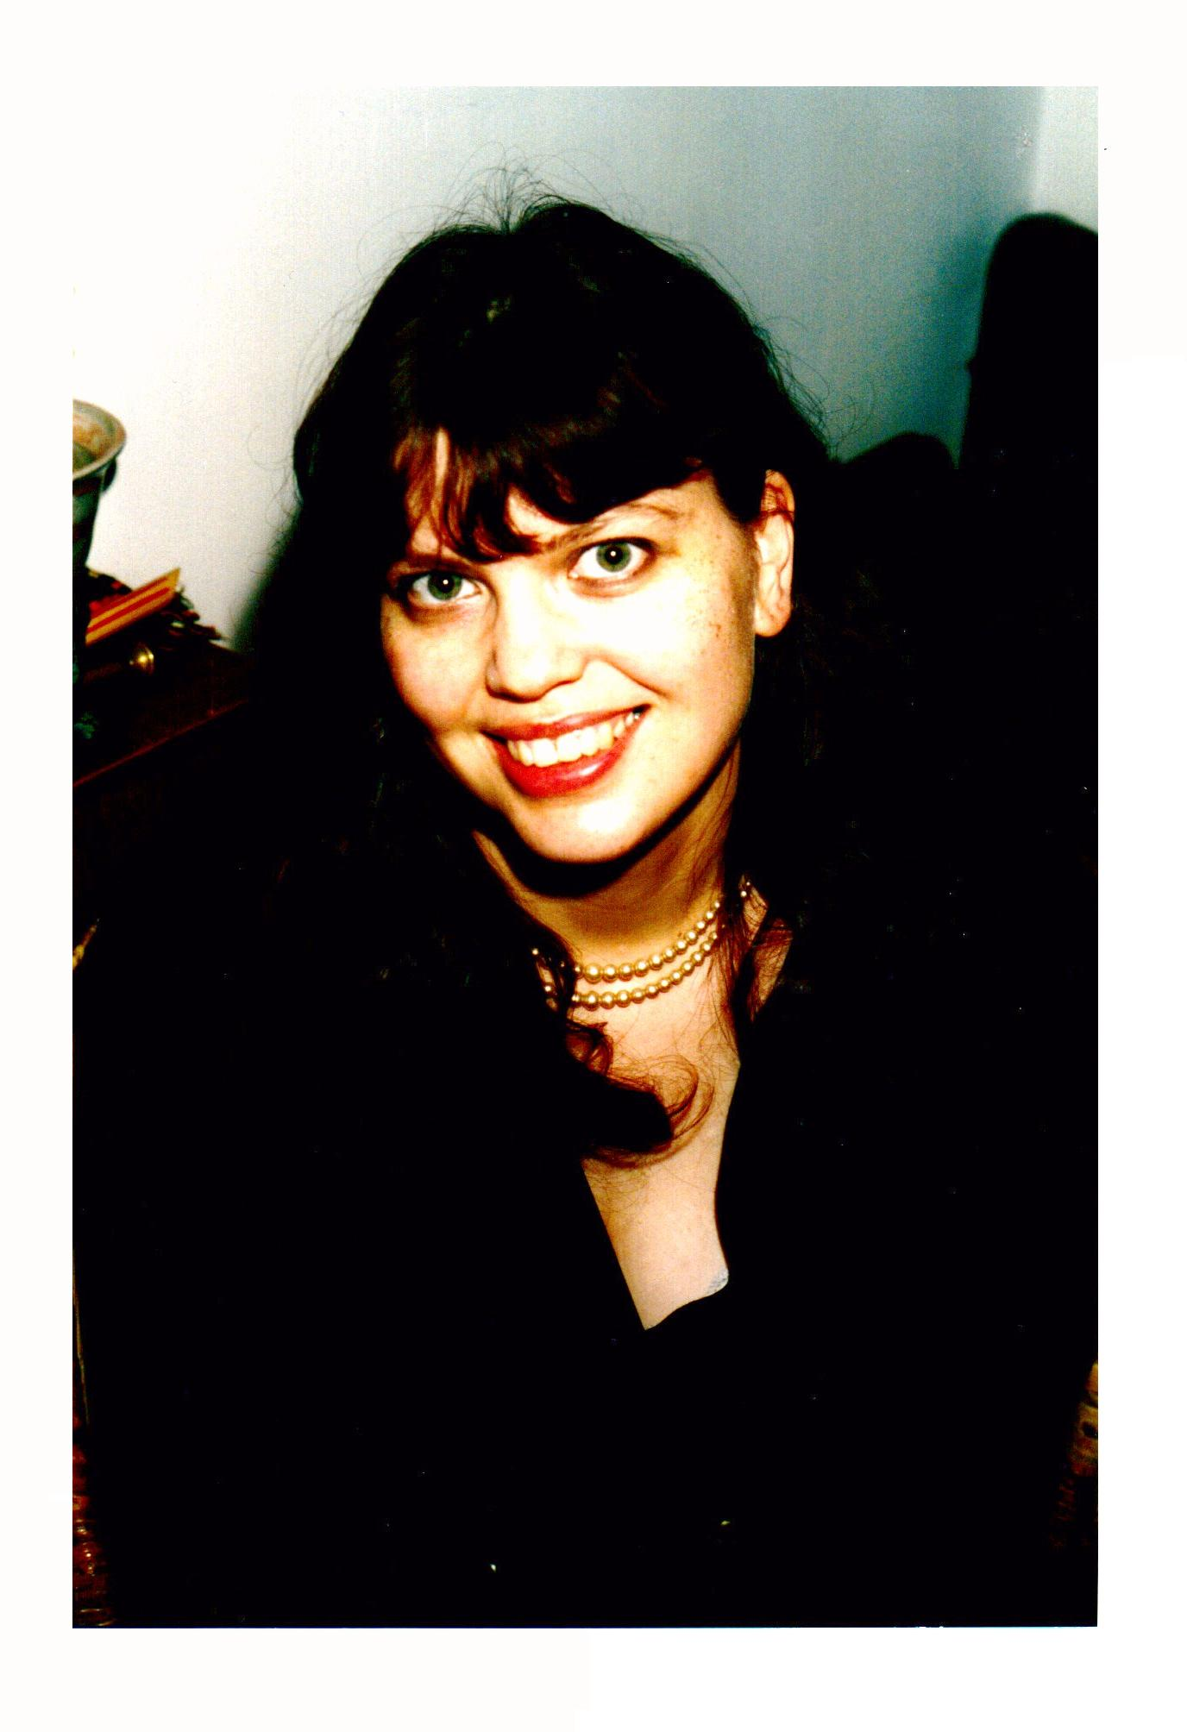
Photo on back cover taken on New Year’s Eve, 1997

